**Launch AWS EC2 instances as Jenkins Slaves using EC2 plugin**

**Pre-requisites:**

* IAM Role
* IAM User (For AWS Credentials)
* Jenkins Master Instance
* Create Security Group for Jenkins Slave
* Create AWS Credentials for USER
* Create AWS Credentials with in Jenkins Master

**IAM Role:**

Goto IAM Service and Click on Roles

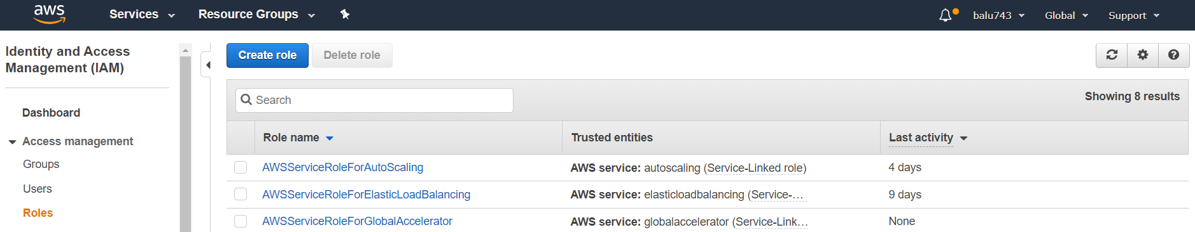

Click on **Create role**

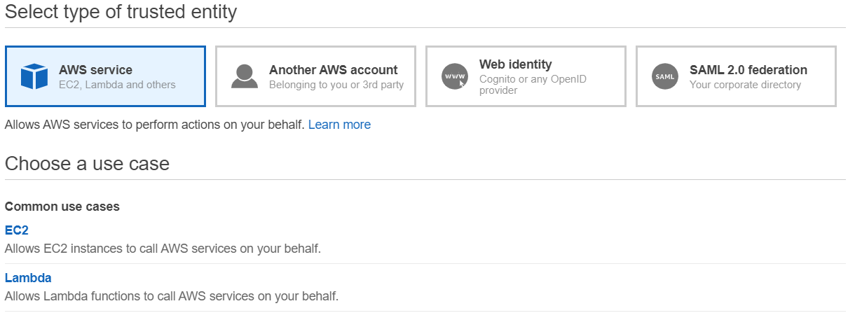

Click on **EC2**

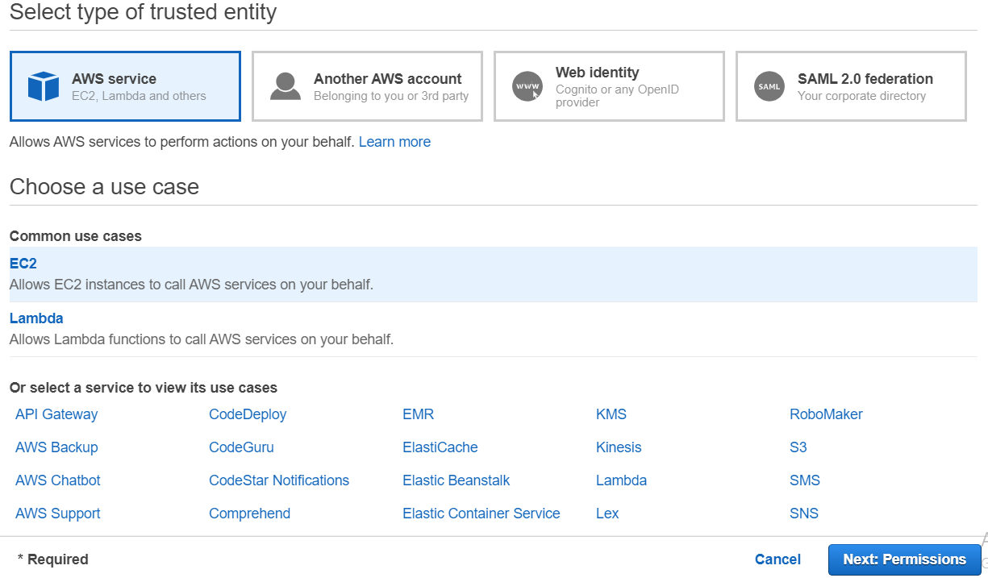

Click on **Next: Permissions**

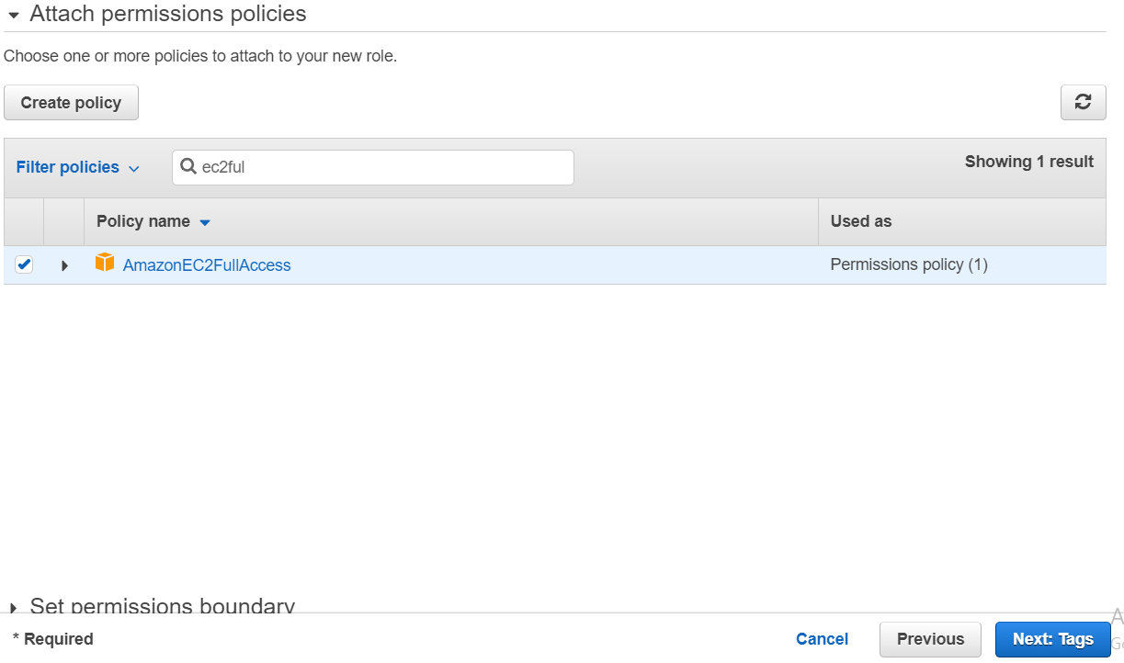

Attach **AmazonEC2FullAccess** policy and click on **Next: Tags**

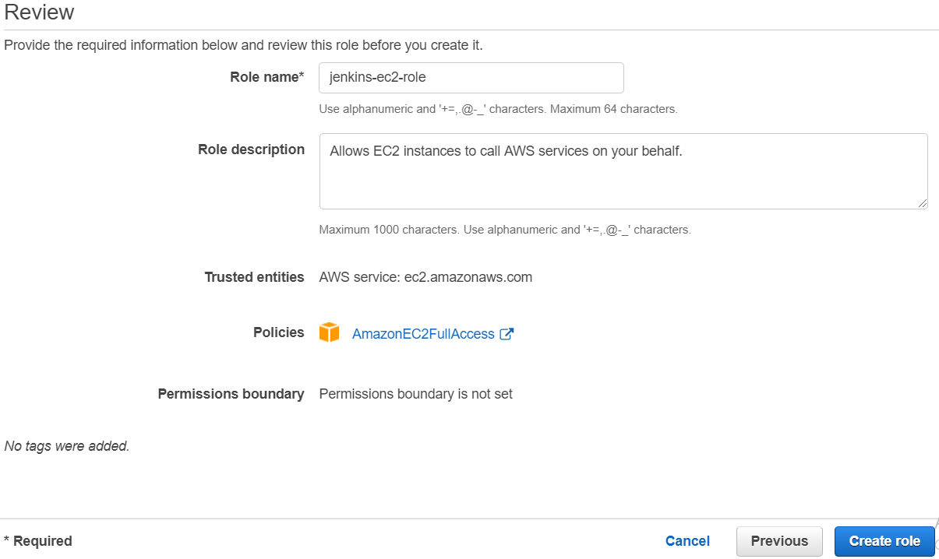

Give Role Name and click on Create role

**Create IAM User:**

Goto IAM and click on user

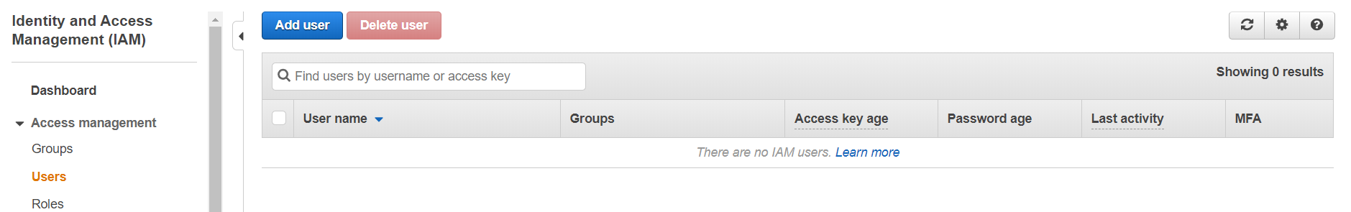

Click on Add user

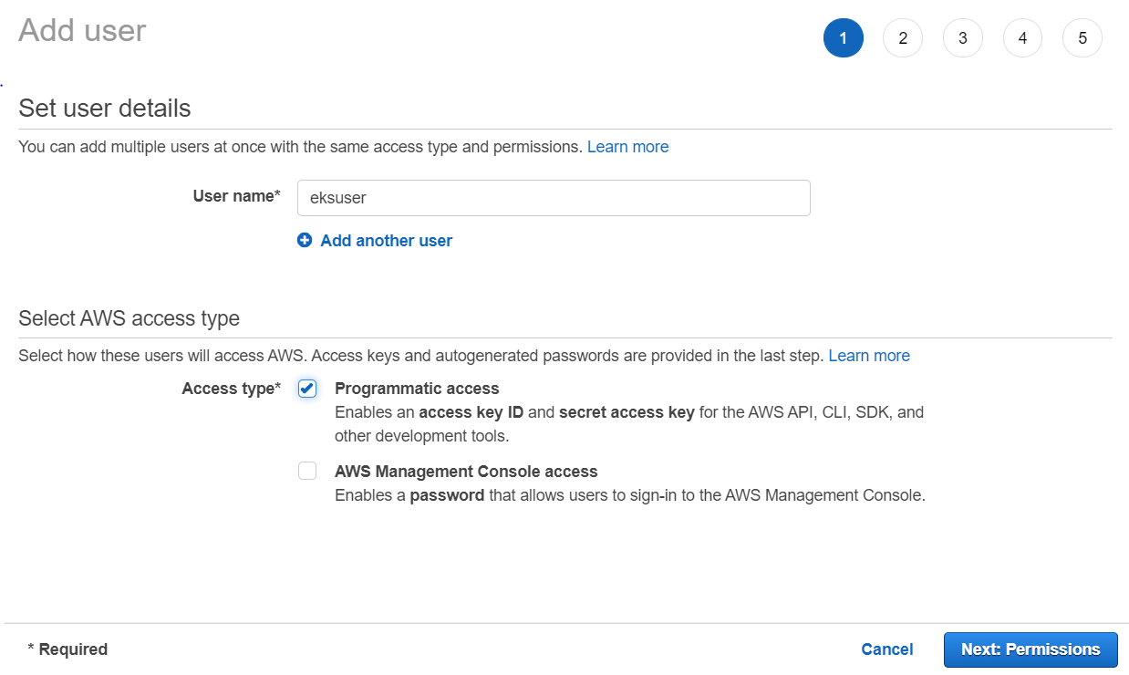

Give any name for user and check Accesstype as Programmatic access

Click on Next

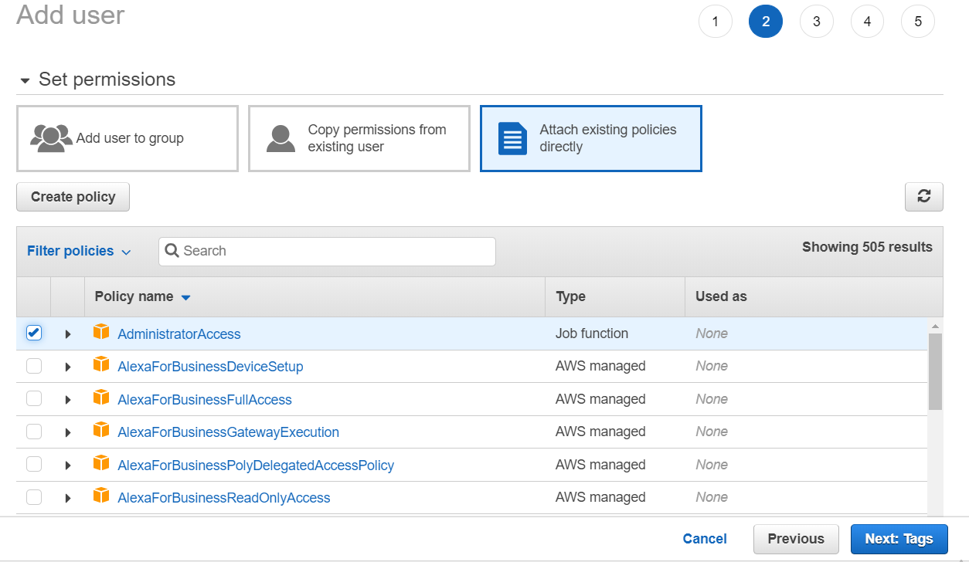

Add tag as Administrator and click on next

Click on create

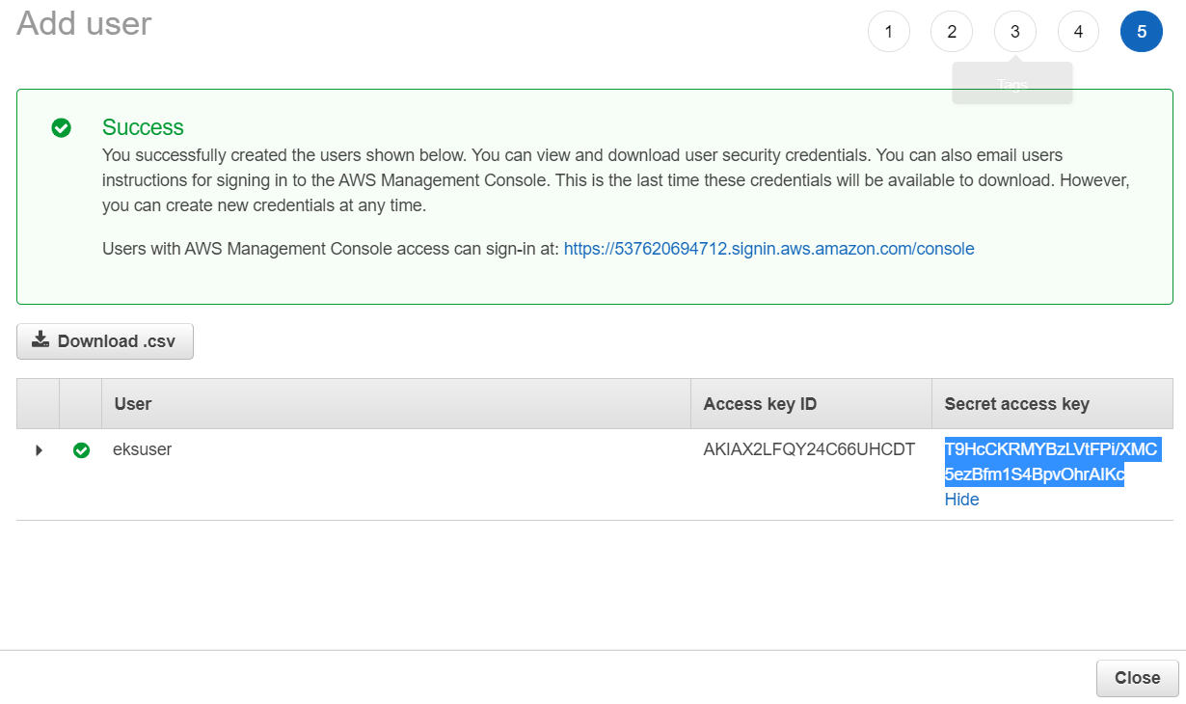

Here user created and copy Access key ID and Secret access key

These Access Key ID and Secret access key gives to configure aws

**Create Security Group for Jenkins Slave:**

Goto EC2 Service 🡪 Security Groups

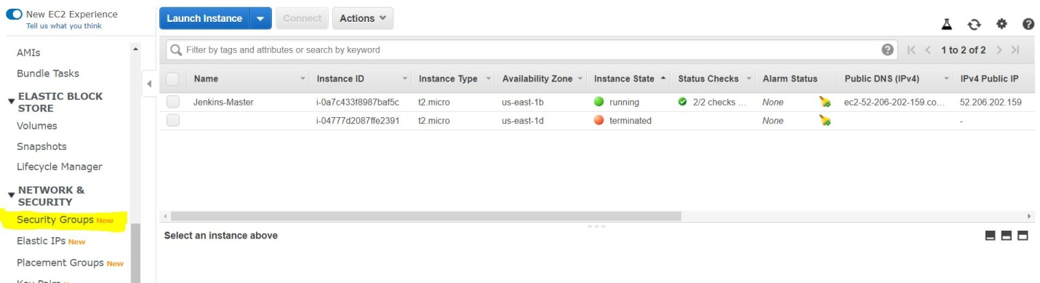

Click on Security Groups

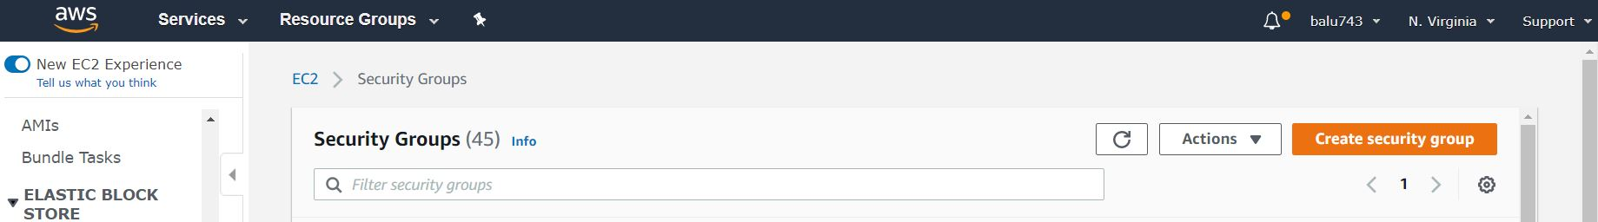

Click on **Create security group**

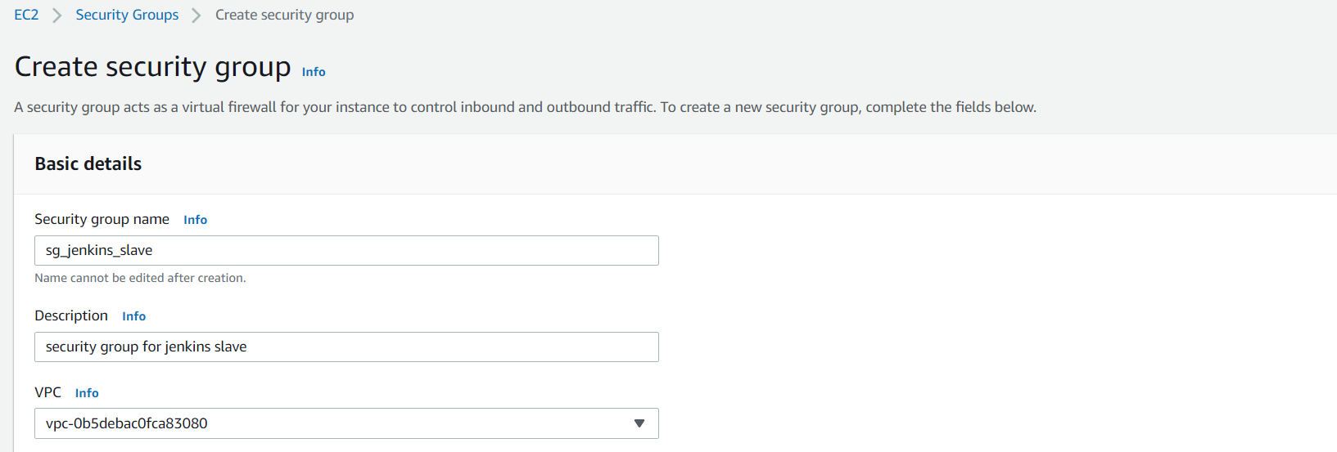

Give details as above and add security group of Jenkins master at inbound rule for communication of Jenkins slave with Jenkins master

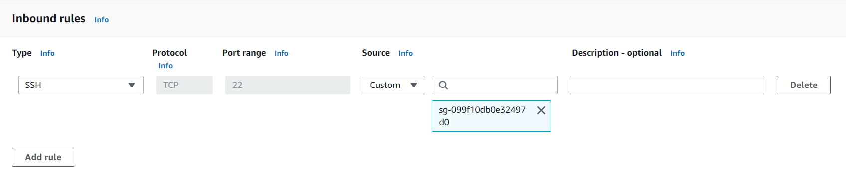

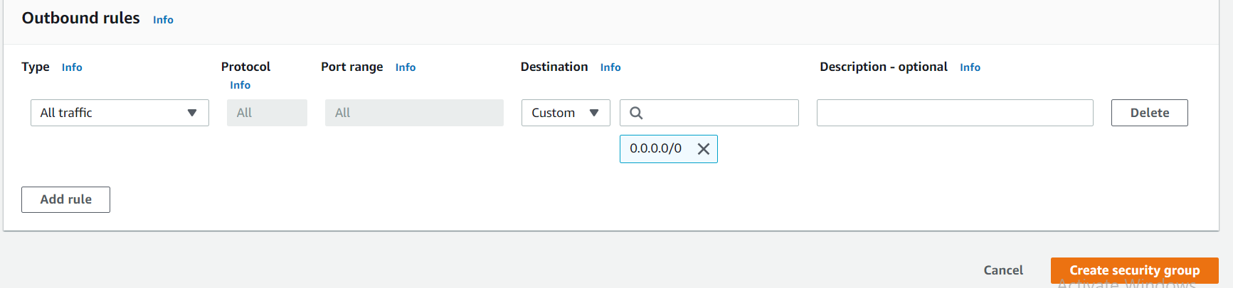

Click on **Create security group**

**Jenkins Master Instance:**

Install Java:

yum install java-1.8.0-openjdk –y

Install Jenkins:

sudo wget -O /etc/yum.repos.d/jenkins.repo http://pkg.jenkins-ci.org/redhat-stable/jenkins.repo

sudo rpm --import https://jenkins-ci.org/redhat/jenkins-ci.org.key

sudo yum install jenkins -y

sudo service jenkins start

Open Jenkins in UI:

<ip-address>:8080

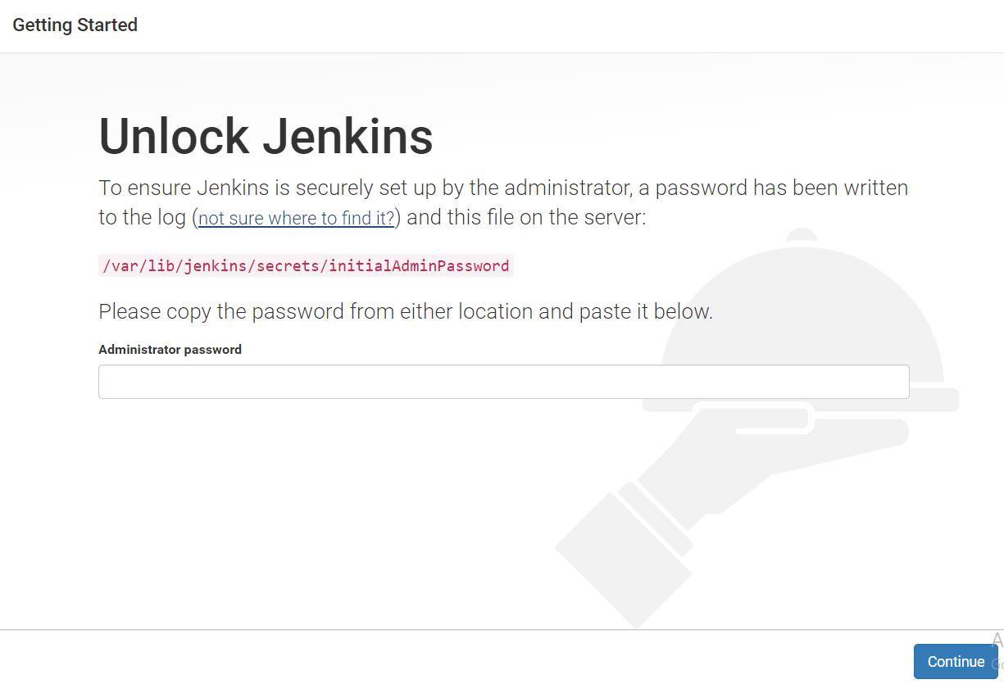

cat /var/lib/jenkins/secrets/initialAdminPassword



Copy password and paste in UI and then Click on **Continue**

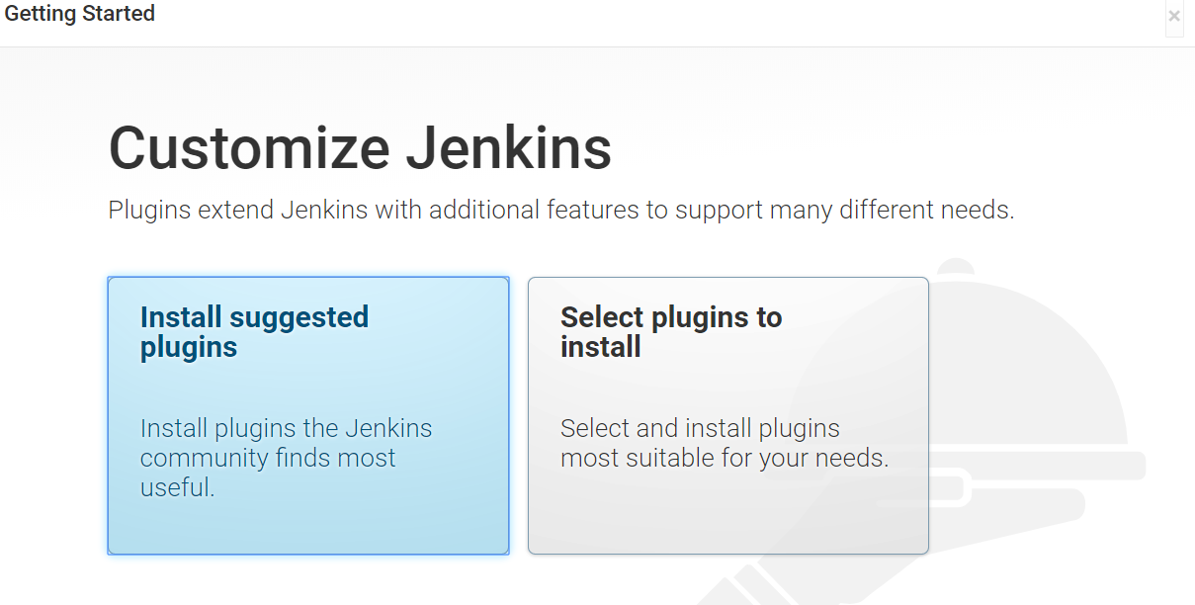

Click on **Install suggested plugins**

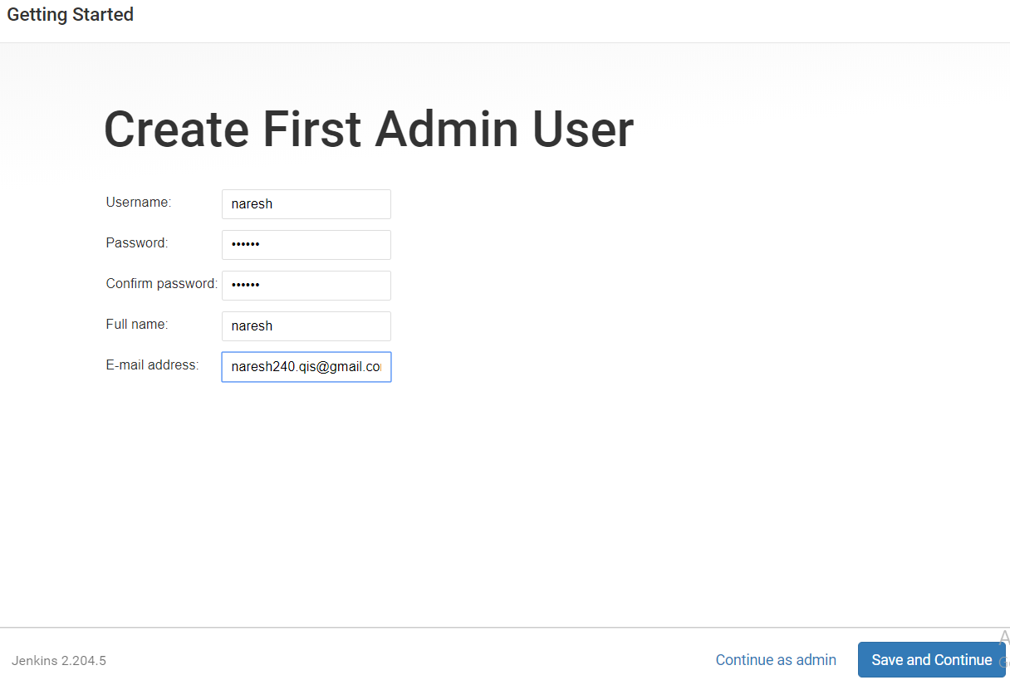

Provide details as above and click on **Save and Continue**

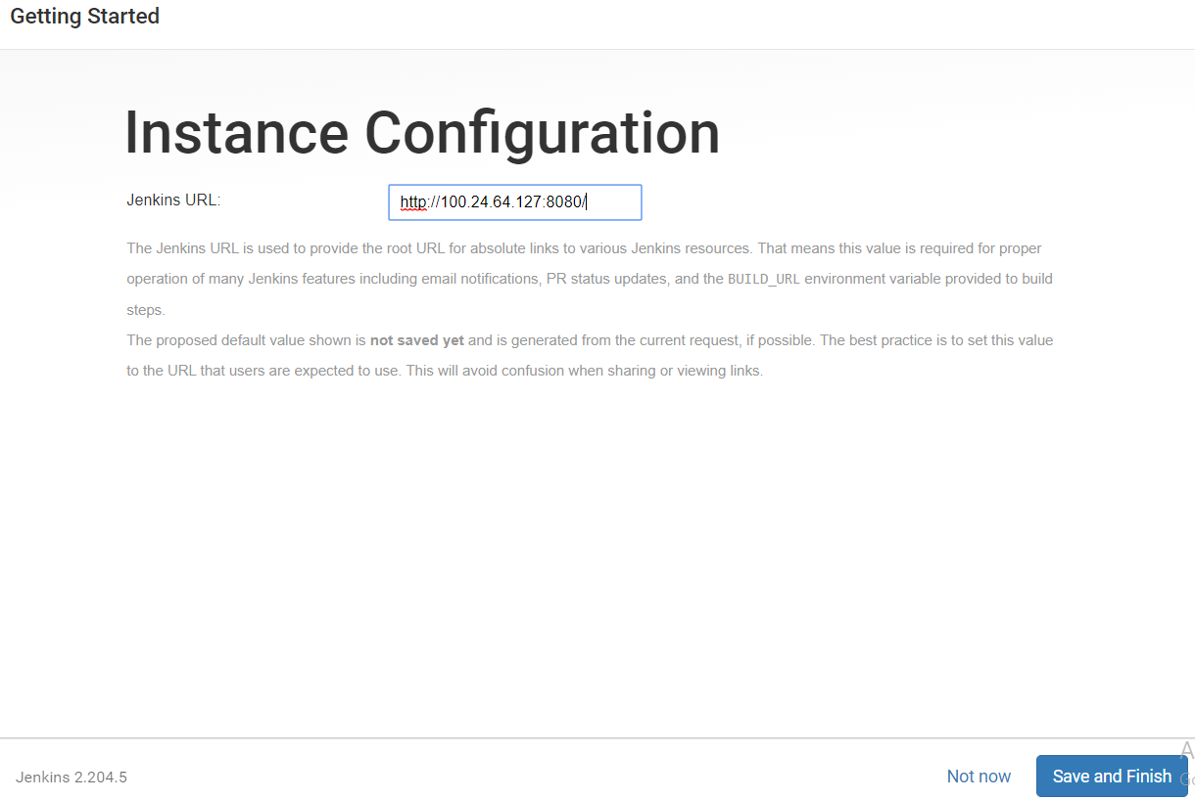

Click on **Save and Finish**

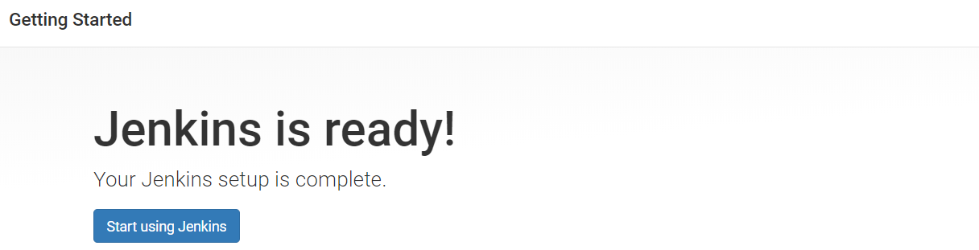

Click on **Start using Jenkins**

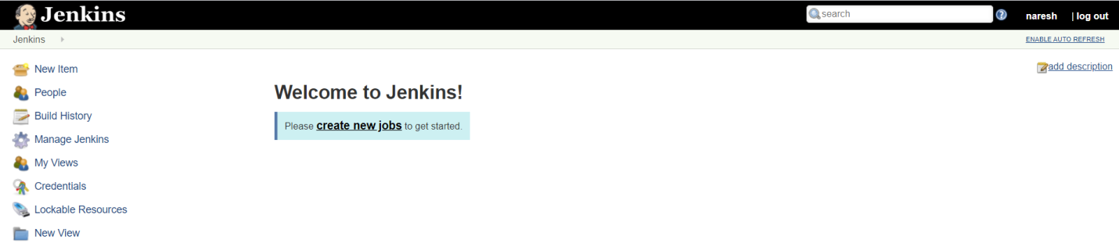

Install **docker plugins** to Jenkins:

Click on **Manage Jenkins**

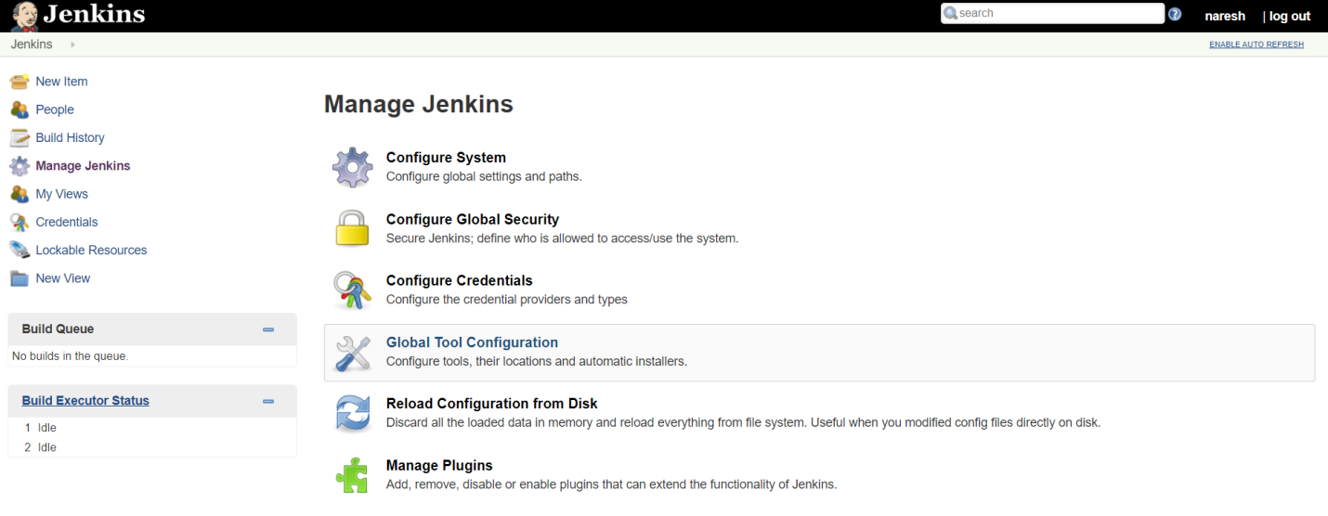

Click on **Manage plugins**

Add **Amazon EC2 Plugins**

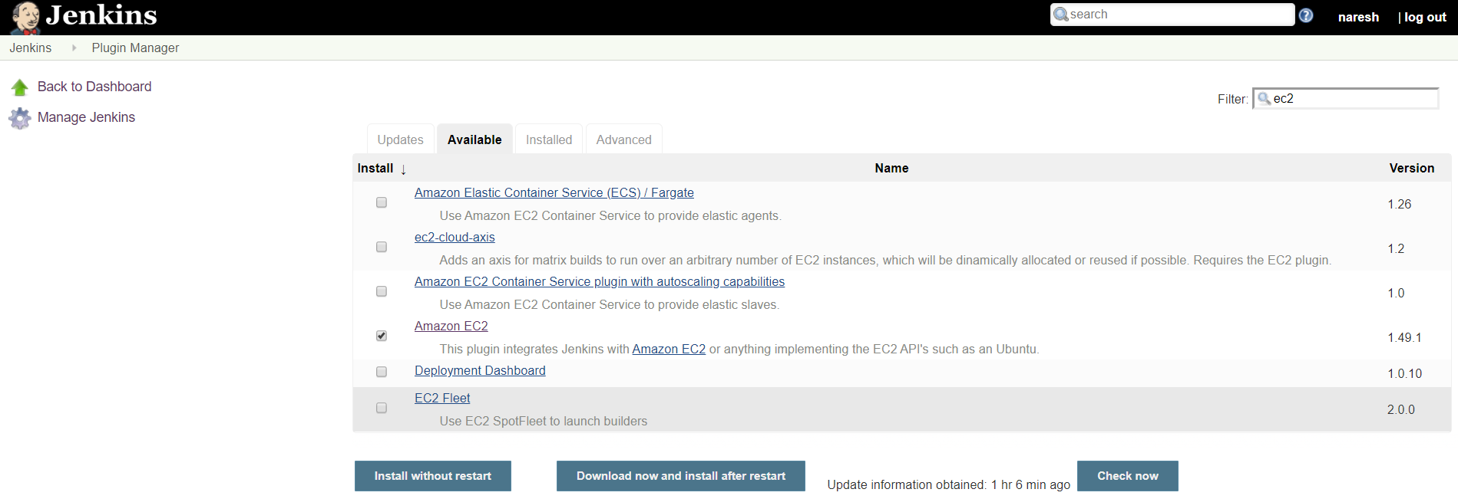

Click on **Install without restart**

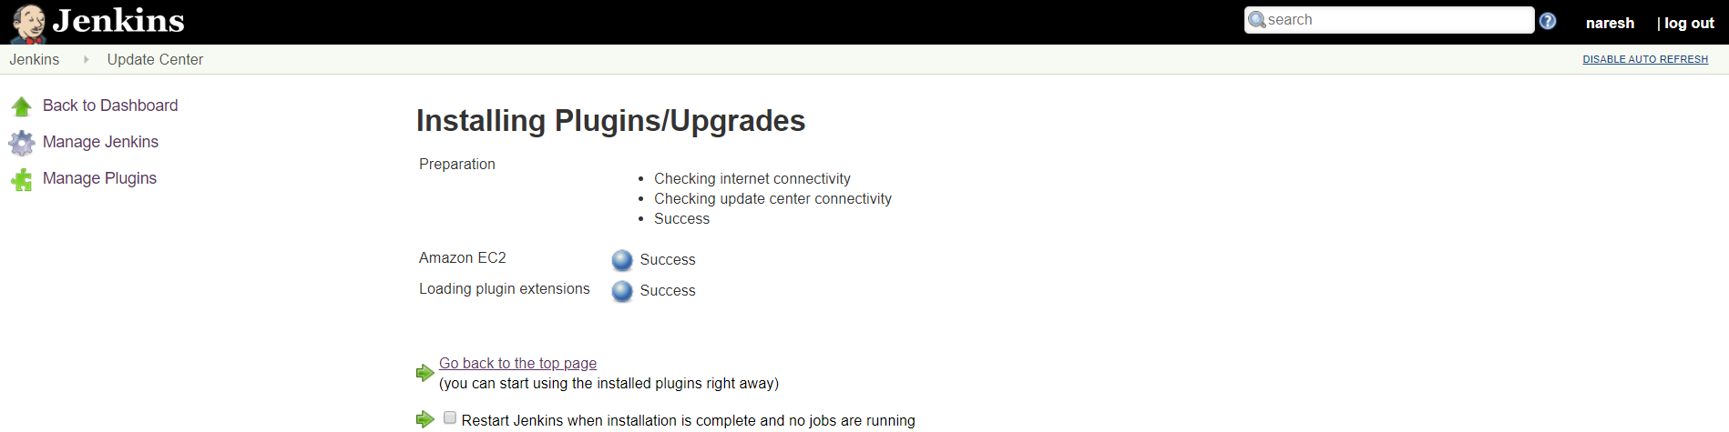

Click on **Go back to the top page**

**Create AWS Credentials with in Jenkins Master:**

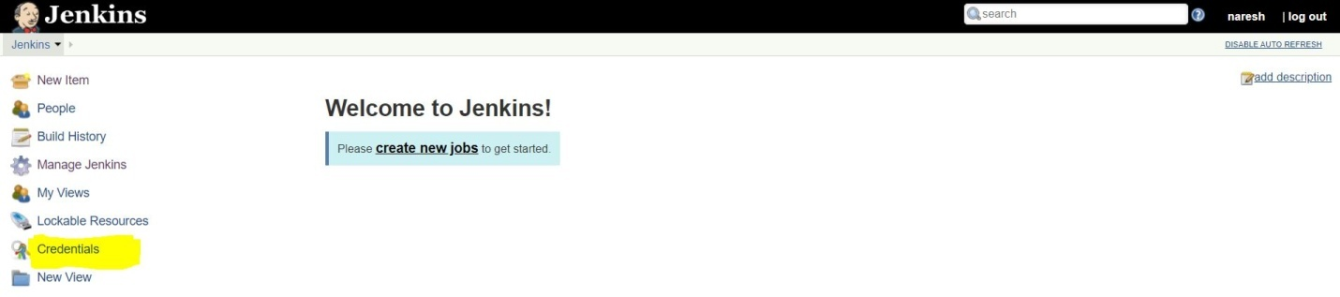

Click on **Credentials**



Click on **Jenkins**

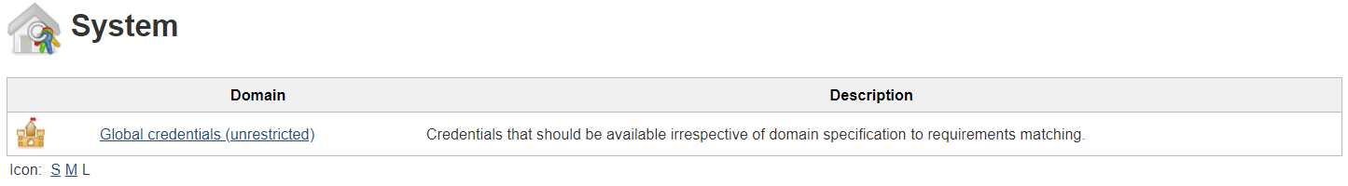

Click on Global credentials (unrestricted)



Click on **Add Credentials**

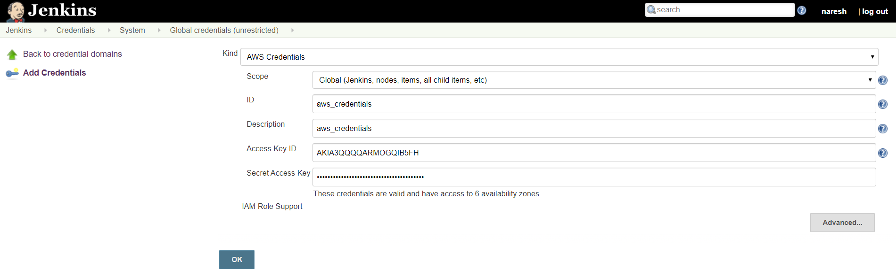

Give details as above

Click on **OK**

**Integrate EC2 with Jenkins:**

Goto Manage Jenkins 🡪 Configure System

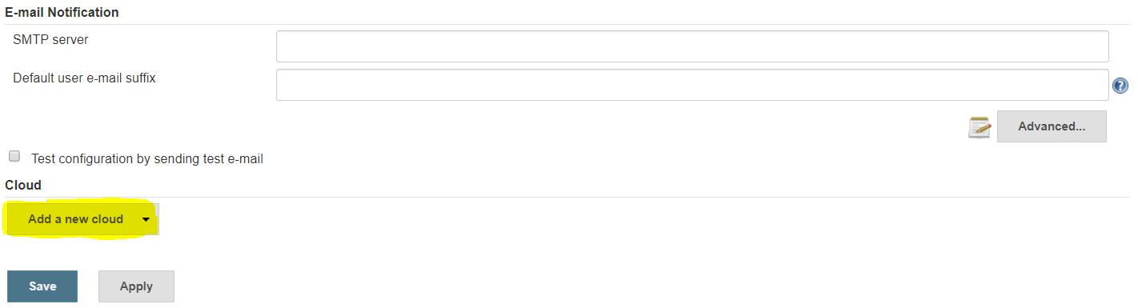

Click on **Add a new cloud**



Click on **Amazon EC2**

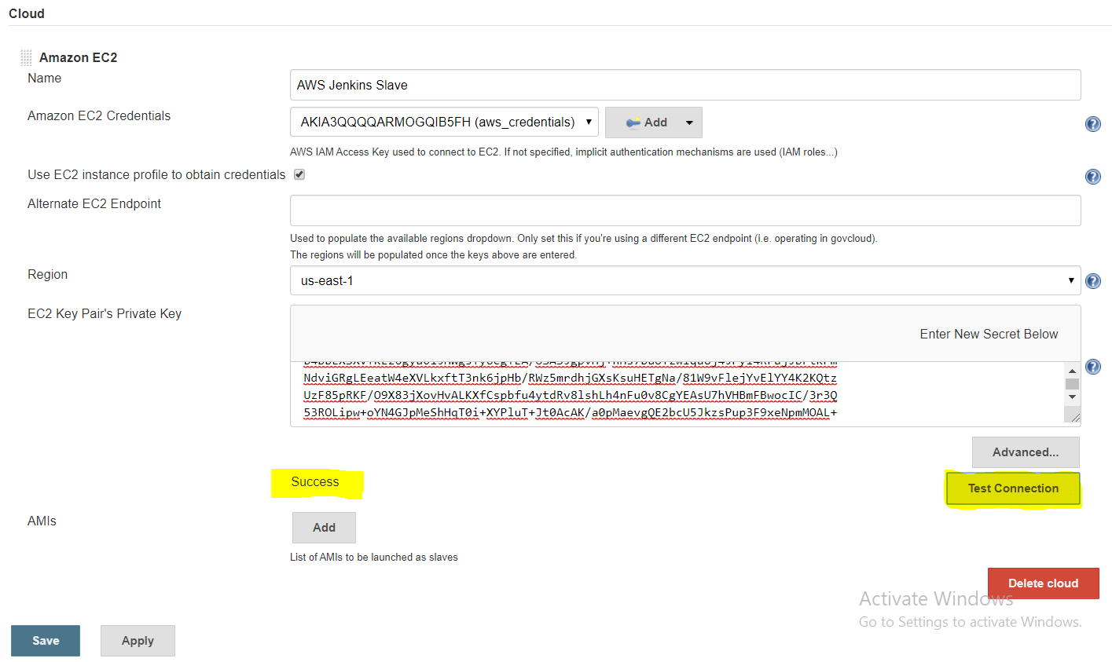

Click on **Add**

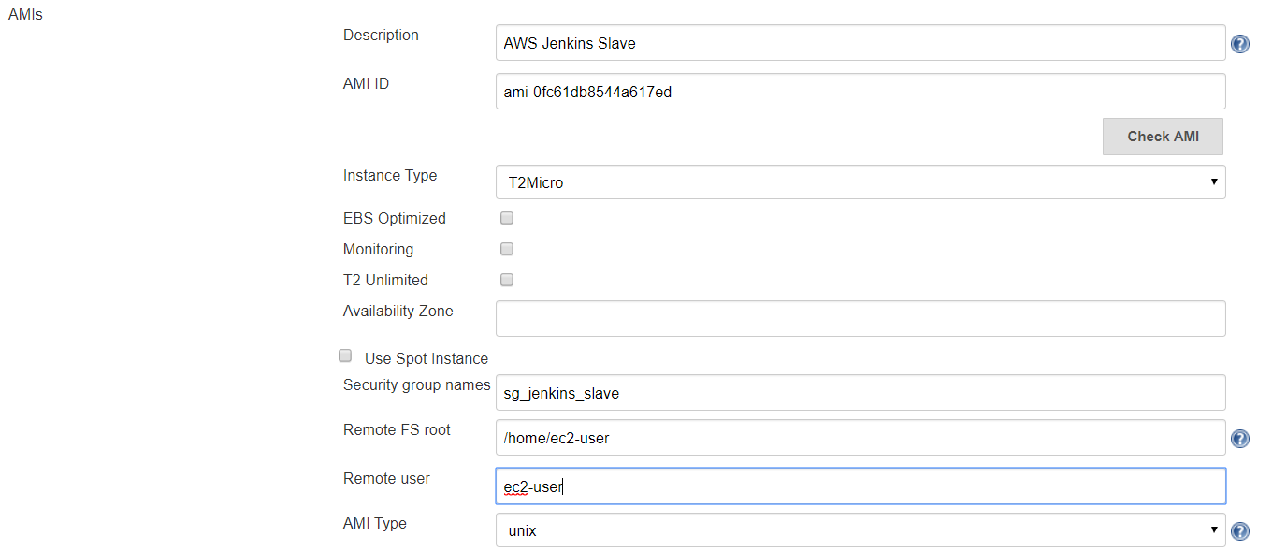

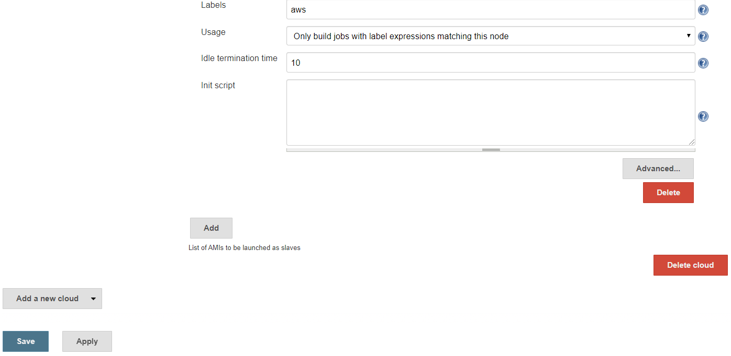

Click on **Save**

**Create Jenkins Job to check whether the slave creating or not:**

Goto Jenkins 🡪New Item

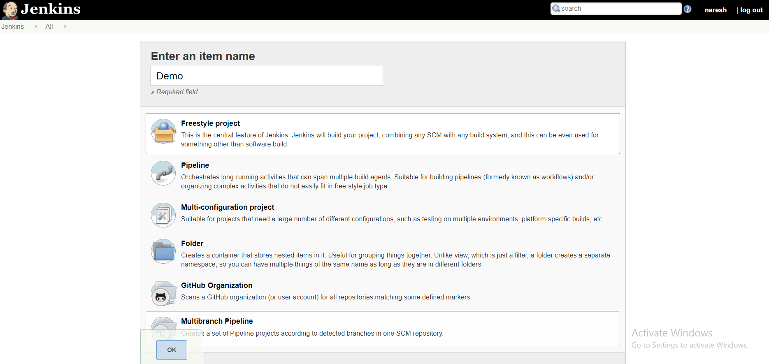

Enter an item name

Click on Freestyle project

Click on ok

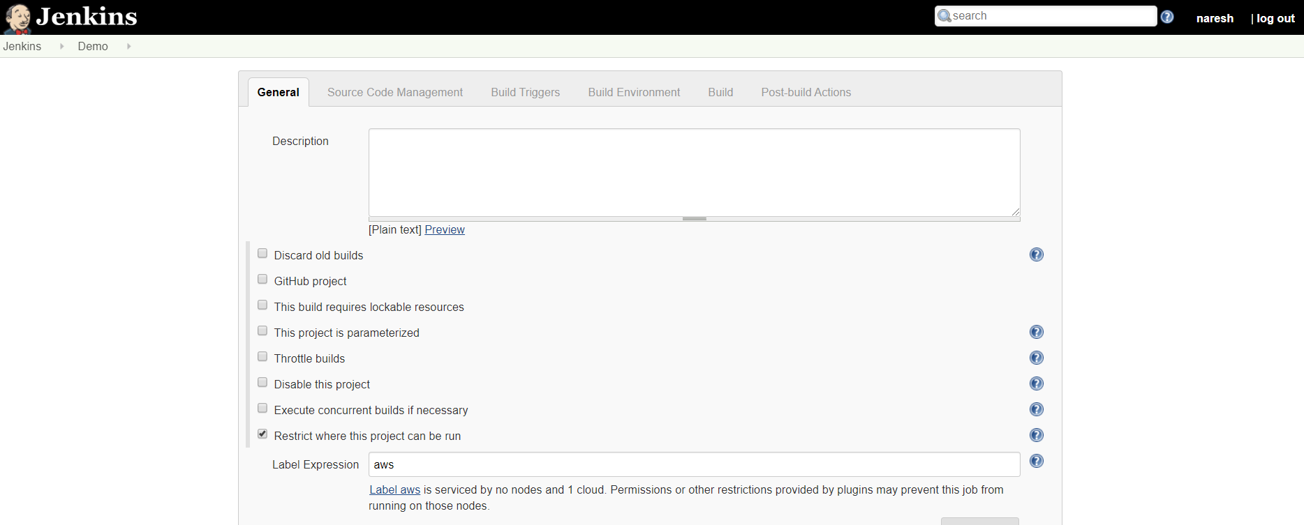

Give lable name

Goto Build Environment and Click on Add build step

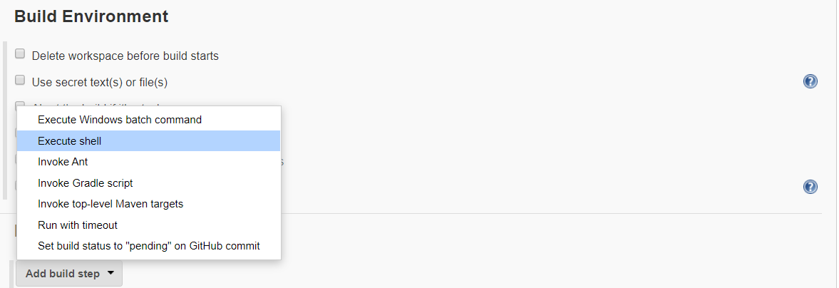

Select Execute shell

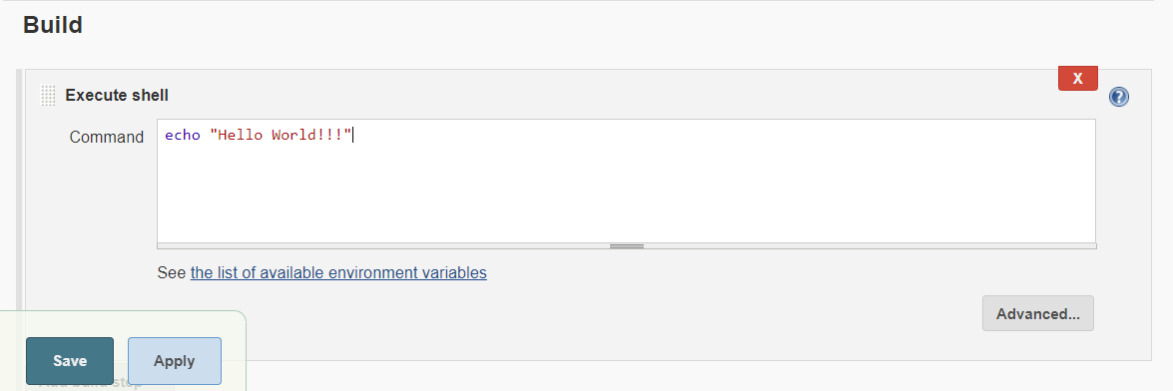

Write command to print something in Console Output

Click on Save

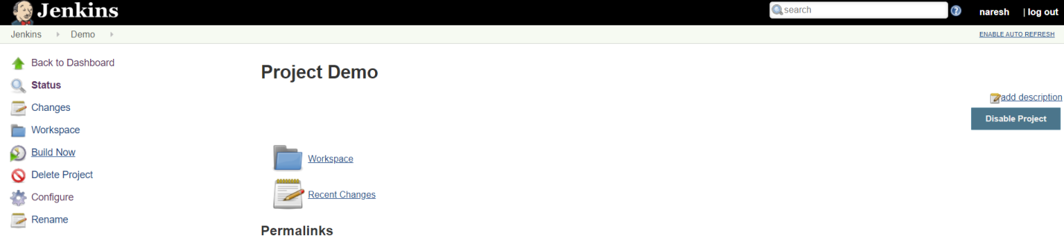

Click on Build

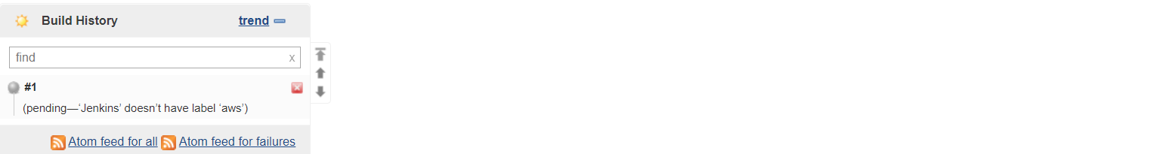

Its will take time for create EC2 Instance creation

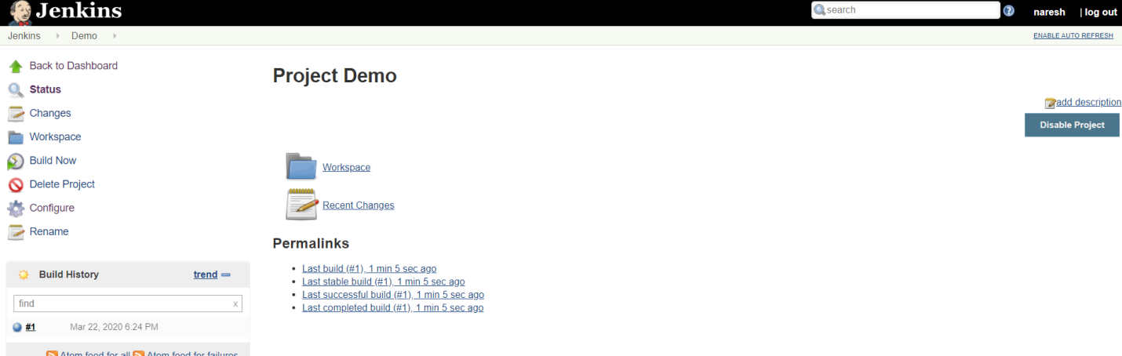

Build Sucsess

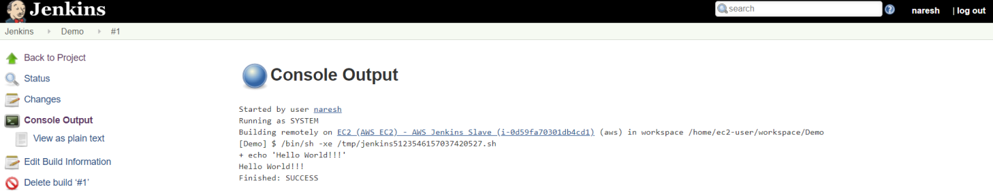

After some time EC2 instance will be terminate where our Jenkins slave created automatically